Installation Instructions for My Personal Encryption
www.DatavisionImage.com
My Personal Encryption has been designed and tested for use on Windows Computers.
It may work on Apple Computers using a program called Boot Camp. With Boot Camp, you can install and use Windows on your Intel-based Mac. Boot Camp Assistant helps you set up a Windows partition on your Mac computer's hard disk and then start the installation of your Windows software. Book Camp has not been tested as an installation tool.
To Install on a Windows Computer do the following:
If you downloaded the software from https://www.datavisionimage.com/encryption then proceed as follows:
- Unzip the file MyPersonalEncryption.Zip
- Click on setup.exe. You may receive some warnings that look like these. Please ignore them and proceed to install.
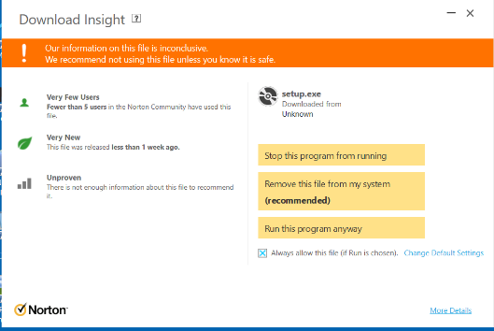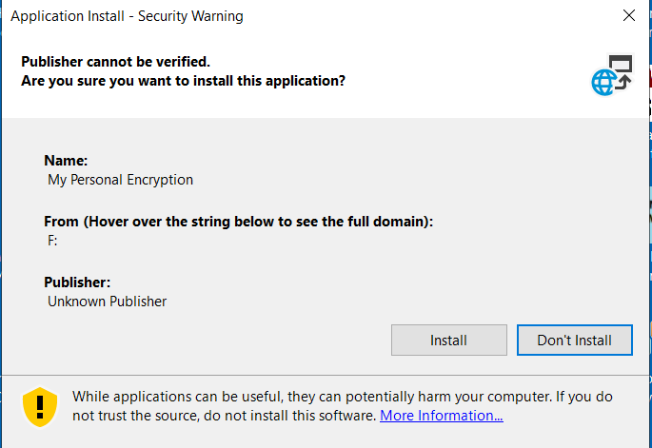

- The program will install on your computer.

The program will install an ICON on your desktop that looks like this:
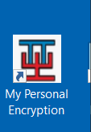
- Each installation requires a License Key which may be obtained from Datavision by emailing the Serial Number produced by the program to
info@datavisionimage.com
You will see the following message boxes each time you run the program before you have entered a License Key:
When you receive the License Key from Datavision via email, enter it on this screen:
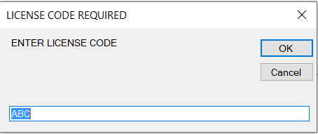

You will receive a License Key once you have paid for the program.

If you purchased the program from Amazon, then you will receive a USB stick and instructions in the mail. To install the program do the following:

- Insert the USB Stick into the USB drive on your computer and locate “Setup.exe”
- Click on Setup.exe. You may receive some warnings that look like these. Please ignore them and proceed to install.
- The program will install on your desktop and show this ICON: The program will open automatically upon installation.
- Each installation requires a License Key which may be obtained from Datavision by emailing the Serial Number produced by the program to
info@datavisionimage.com
You will see the following message boxes each time you run the program before you have entered a License Key:
When you receive the License Key from Datavision via email, enter it on this screen:

You will receive a License Key once you have paid for the program.
Using the Program
To use, simply cut and paste any text you want to encrypt into the Plain String text box, select a password, and press “Encrypt”. To decipher an encrypted text, simply cut and paste the encrypted text in the Encrypted String text box and press De-Encrypt.
The install files on the USB stick or in the MyPersonalencryption.zip file contains a test encrypted text message called “Encrypted with Becky40.txt” which you can cut and paste into the Encrypted String text box. You can only decrypt messages if you know the password. The password for the test message is “Becky40”. When you begin to use the program you may select any password to encrypt the files to encrypt your data.
Here are a few screens:
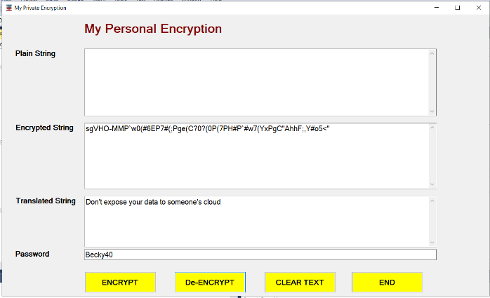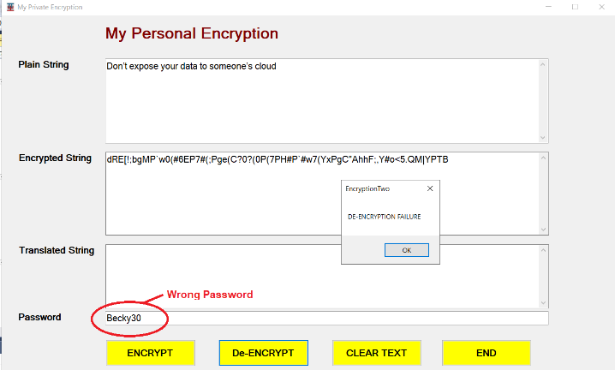
For assistance please email us at
info@datavisionimage.com
You may install the program on as many windows computers as you want, but each program is billed and will require a new unique License Key. Feel free to send the USB Stick to friends or send them the download link (www.datavisionimage.com/encryption ) so you can use encrypted data on emails, face book, twitter, or any other social media.
KEEP YOUR PERSONAL DATA PERSONAL

