DATAVISION IMAGE LLC
906 Via De Angeles
San Clemente, CA 92672
info@datavisionimage.com
949 429 8175 Office
617 851 9104 Cell

Technical Details of Signature Recognition

Introduction

The Identi-Sig Signature Recognition API described here will allow a programmer to easily add Signature Recognition Capabilities to any Windows application including those written in VB.Net, C#.Net and Visual Studio ASP.Net

The product described in the following pages is written as a 64 bit DLL. The version described here is called Identi-Sig DLL.

The DLL allows the images of two signatures to be compared and returns a value indicating the likelihood of a match. The Identi-Sig algorithms do not use a database but the application containing the Identi-Sig API does use a database. The “My Personal Signature Recognition” application has a built in Access database, which can easily be upgraded to MySQL or other larger external database. Please contact Datavision for assistance changing the connection string and database source.

Signature Recognition is not an exact science. In this product, Signature Recognition is done by measuring features of a signature and recording these measurements in a string called an Electronic Signature. This product uses 57 measurements. When the signature is stored in the database the Electronic Signature is stored with it to improve the speed of comparison. When a comparison is made, many instances of the signature are considered before a final comparison value is returned by the algorithms.

The Signature Recognition DLL will make a comparison between two signatures by comparing the measurements in two different ES records, then applying various statistical analysis techniques to the comparison to determine the number of the features that match.

Determining a match involves some complex calculations, and some adjustments based on many years of experience dealing with this subject.
The answer to the question “Is a 395 value from one signature the same as a 733 value from a sample signature?” can be found by using Artificial Intelligence algorithms to process data from hundreds of thousands of comparisons. Based on the data patterns for feature values for this measurement the distribution can be derived for a particular algorithm. We can then infer the single sample value is distributed a certain way, and from that can predict the reasonable limits for a given measurement.

Based on over 20 years of experience DATAVISION is very familiar with the behavior patterns for different type measurements. That knowledge is incorporated in the Identi-Sig API and the results are quite accurate.

As it turns out, binomial kind of logic/mathematical rule sets prove pretty good. They are not perfect, but an accuracy of over 97% has been achieved. In addition to the math, each dataset of signatures will produce a different result depending on quality and noise in the image. Those characteristics can be fined tuned by adjusting the quality of the image input settings (accuracy) available in the algorithm.

The Identi-Sig API is only used for STATIC (image based) signature comparisons. The Static Signature Recognition model uses 57 measurements. We have used a binomial distribution to assist in the calculations. If one were to flip a coin 58 times, we may expect to get 29 heads and 29 tails. This might mean in our example if you get 29 features that match and the likelihood of any feature match being accurate is 50% then getting 29 matches could be the same thing if you just got random results. So, in the DLL the distribution of features is assumed to follow a binomial distribution and using tables for this distribution we find the probably the features are not distributed at random increases steeply as the number of features increases from 29. In English, this means getting 29 will yield a score of 0% likelihood because we could get such a score with two random signatures. Getting a higher score starts to dramatically increase the likelihood of a match as the number approaches 57 and stays low as the number becomes less than 29.

It’s all based on statistics, and not real results. There are other factors because not all signatures are the same. In banking applications where a signature is written over and over on a check, for example, the signature tends to resemble the signer’s name, and tends to be the same. In other industries such as checking signatures on prescriptions, the doctor’s signature may be only a “squiggle” and not represent the signer at all. In both cases we have found the percent match returned is fairly consistent and in one population a 65% return means the signers are very much the same signer, while in other populations, a 85% or higher may be needed to assure the signers are the same. In mortgage applications, the signatures are quite alike so it is easy to detect where a fraud has been used on a document.

The Identi-Sig API considers that signatures will be different not just in the way the signature is drawn but also in actual signature itself.

The Process
Signature images are introduced to the algorithms via a file. The image can be in any popular file format such as BMP, JPEG, TIFF, PNG, PDF, etc.
The first step in the process is the algorithms change all file formats to a BMP image format. The image is then “normalized” so it occupies the same window size for height and width. Next the image is scrubbed to remove as much noise as possible.
All images in the Identi-Sig API are managed as memory streams. This means that the API can run in server environments where image pages are not permitted as well as in desktop applications.
All images are changed to one bit level BMP images, and then further scrubbed to eliminate the RGB characteristics associated with one bit images.
The image is then manipulated so each dot in the image is addressable. This process is called Binarization. After the image has been properly prepared, it is subjected to analysis by 57 different algorithms, and the results are recorded into an Electronic Signature.
Comparison are done by comparing one Electronic Signature to another. Scoring is a complex process that considers not only single Electronic Signature comparisons but also considers the results of several events occurring. It’s complex.

Using the API
Using the API is very simple.
The “My Personal Signature Recognition” application does not require any programming. Just use it and the results will be returned automatically. If you like the accuracy of the “My Personal Signature Recognition” application, please contact us to purchase a license for either a single or multiple copies of the Identi-Sig API. The application requires a key that can be obtained from us after you have paid for the product.
If you want to start building your own application with the Identi-Sig API, here are the steps to do so..
Here are the steps a programmer would use if you want to write your own Signature Recognition application. If you purchase a single copy of the DLL, please contact us for details about how to unlock the DLL for custom use. There is a code necessary to use the “My Personal Signature Recognition” software. Please follow the instructions on the screen to obtain your unlock key. When programming with the Identi-Sig API, the only commands necessary to operate the API are as follows:
- Instantiate the DLL.
Public MySignatureRecognition As New IdentiSig.IdentiSig
- Public Function GetDLLVersion ( returns the API in use)
- Public Function GetESString (used to specify the signature image file to use)
- Public Function SetPrecisionLevel ( sets between 0 – 9, with 9 the most precise)
- Public Function GetMasterES22( returns a Master ES calculated from the File chosen)
- Public Function CompareSignatures22 (the function that compares the signature to the data stored in the database. It basically does all the work)

Installation Instructions
The “My Personal Signature Recognition” program is installed using the setup.exe in the folder “Install My Personal Sig Recognition”. This folder contains a folder named “C:\SigRecDB”. This folder contains an access 2000 database (“MySigRec.mbd”). IMPORTANT: Please copy this folder to your C:\ drive BEFORE you click on Setup.exe.

Once you have copied the “C:\SigRecDB” folder to C:\ you may install by simply clicking on setup.exe.

License Requirements: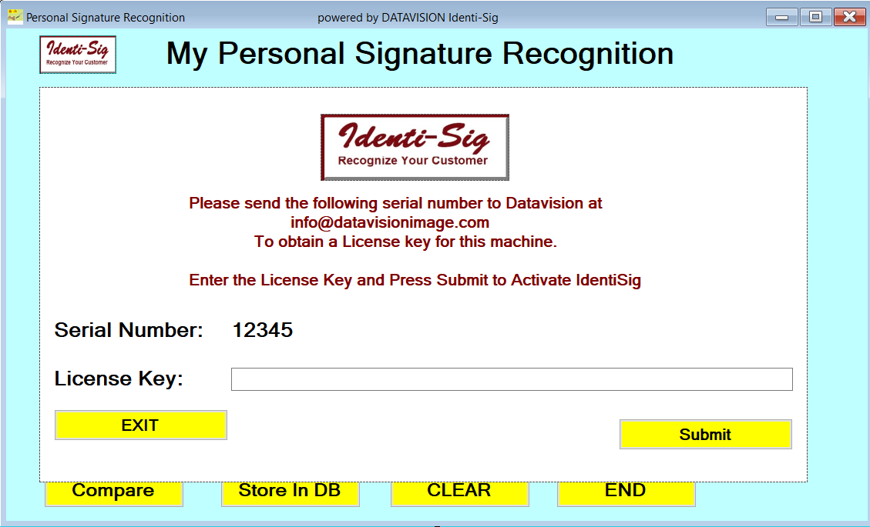
When you first install the My Personal Signature Recognition program the program will request a License Key. It will show you a long string of characters which is the Serial Number for the IdentiSig API. You MUST enter a valid License Key, or the program will not run.
If you are considering just adding the DLL to one of your programs, the DLL also requires a valid License Key to operate.
Copy the serial number shown and email it to DATAVISION at
info@datavisionimage.com
When you have paid for the program, we will send you the necessary License Key. Enter this key in the text box shown,
Cost
The cost of a single copy of the “My Personal Signature Recognition” program is $295.00. This application is designed to give a prospective buyer a way to evaluate just how effective the Identi-Sig API is using images supplied by the user.
The Identi-Sig API is based on many years of experience and hard work.
The cost for an IdentiSig API license you can use in your programs is much higher.
Please contact DATAVISION IMAGE LLC for pricing details.
DATAVISION charges an hourly rate and will offer a fixed price for various projects involving Signature Recognition. Please call or email us to discuss details.

DATAVISION IMAGE LLC
906 Via De Angeles
San Clemente, CA 92672
info@datavisionimage.com
949 429 8175 Office
617 851 9104 Cell

